

Given A logo for the Analysis of the Car Sales, Cars Details And Car Supply Chain Management Dataset and prepared a visualization. This the is the first page of the visualization. Navigation Button created to slide within the visuals for analyzing different features.

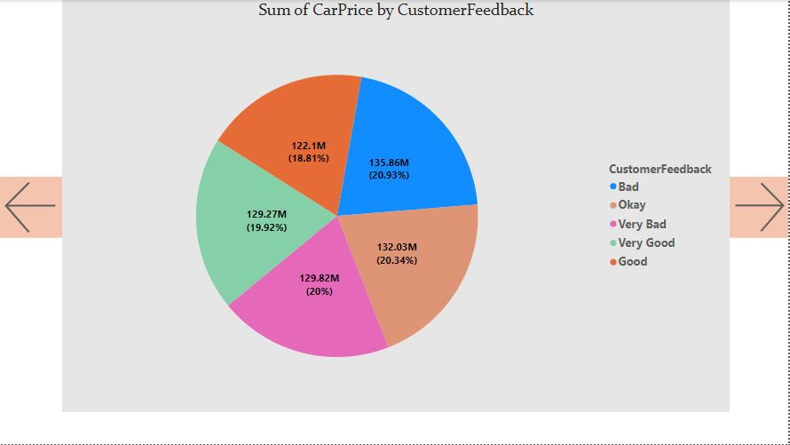

* Customer feedback is split into four categories: Very Bad, Bad, Okay, and Very Good.
* The slice labeled "Good" has the largest portion of the pie chart, at 20%. This means that the sum of the prices of cars with good feedback is 20% of the total sum of all the car prices.
* Slices labeled "Very Good" and "Okay" each account for around 20% of the pie chart. This means that the sum of the prices of cars with very good and okay feedback is each around 20% of the total sum of all the car prices.
* The slice labeled "Bad" accounts for the least portion of the pie chart, at 18.81%. This means that the sum of the prices of cars with bad feedback is 18.81% of the total sum of all the car prices.
* The slice labeled "Very Bad" accounts for around 19.92% of the pie chart. This means that the sum of the prices of cars with very bad feedback is 19.92% of the total sum of all the car prices.

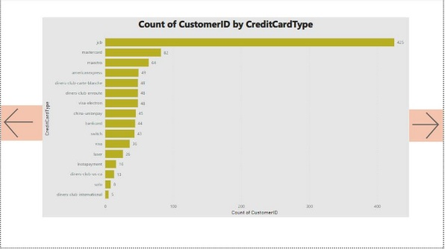

The bar chart shows the number of customers by credit card type. The most common type of credit card is **JCB**, with **425** customers. Here's a breakdown of the number of customers by credit card type:

* **JCB:** 425 customers
* **Mastercard:** 82 customers
* **Maestro:** 64 customers
* **American Express:** 49 customers
* **Diners Club Carte Blanche:** 48 customers
* **Diners Club Enroute:** 45 customers
* **Visa Electron:** 45 customers
* **China UnionPay:** 45 customers
* **Bankcard:** 44 customers
* **Switch:** 43 customers
* **Visa:** 36 customers
* **Laser:** 26 customers
* **Payment:** 16 customers
* **Insta pay:** 13 customers
* **Diners Club International:** 12 customers
* **Solo:** 10 customers
* **Diners Club US:** 8 customers

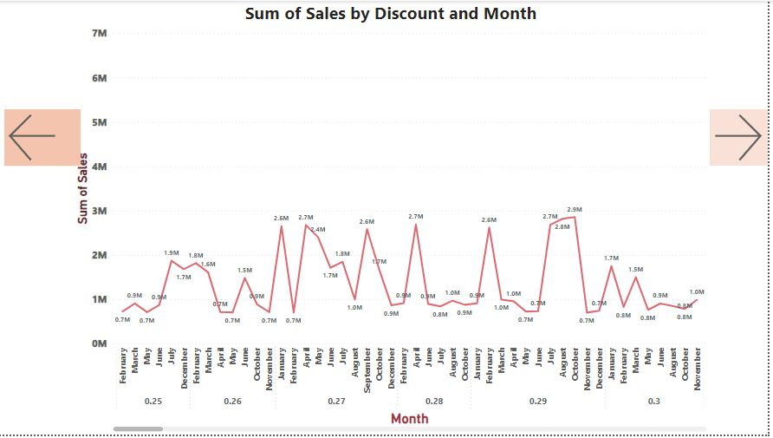

* Overall sales appear to be higher in the colder months (October to March) compared to the warmer months (April to September). This could be because people are more likely to buy cars during the winter months when they are not using their cars as much and are looking for deals.
* The discount that appears to have the most sales throughout the year is 0%. This suggests that customers may be more price-sensitive and are more likely to purchase a car if there is no discount offered.
* There is a spike in sales in December, specifically for cars with a 0% discount. This could be due to year-end sales and people looking to take advantage of tax breaks before the end of the year.

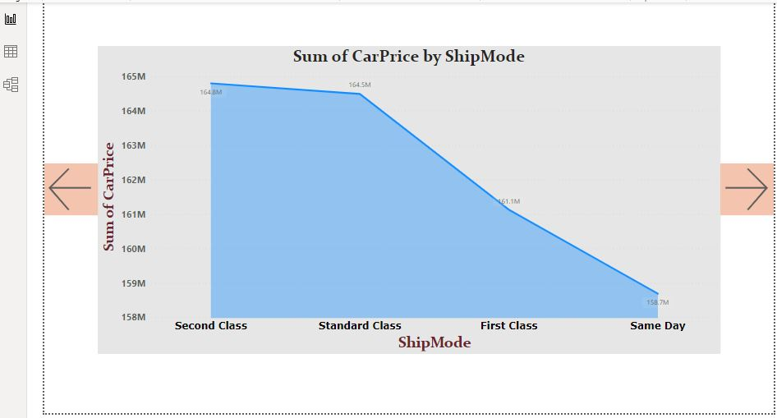

The x-axis shows the different ship modes, which are First Class, Second Class, and Standard Class. The y-axis shows the sum of car prices.

Here are some observations from the graph:

* The sum of car prices is highest for First Class, followed by Standard Class and Second Class. This means that the most expensive cars were shipped using First Class, while the least expensive cars were shipped using Second Class.
* There is a significant difference in the sum of car prices between First Class and Second Class. The y-axis does not have a scale, but the difference in the height of the bars for First Class and Second Class is visually large.

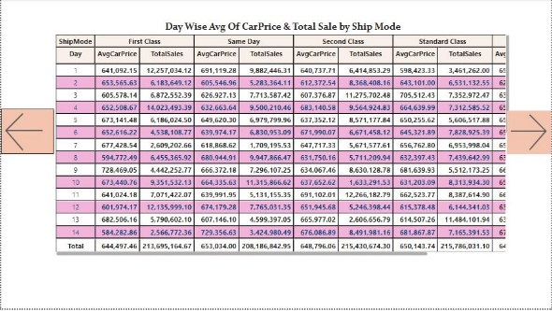

A day wise Average Car price and Sales Analysis by ship mode using Matrice plot in Power BI.

Formatted the matrices for better grouping and to summarize the data in the plot.

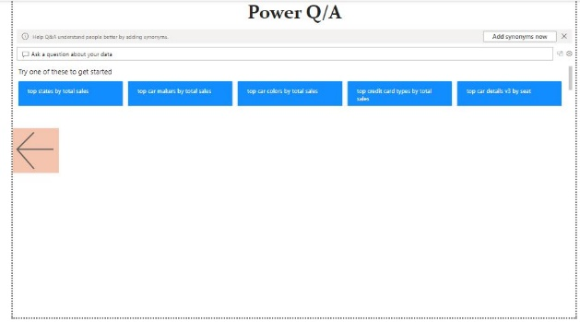

Q/A for my Dash Board of my Datasets which are analyzed using Power Bi